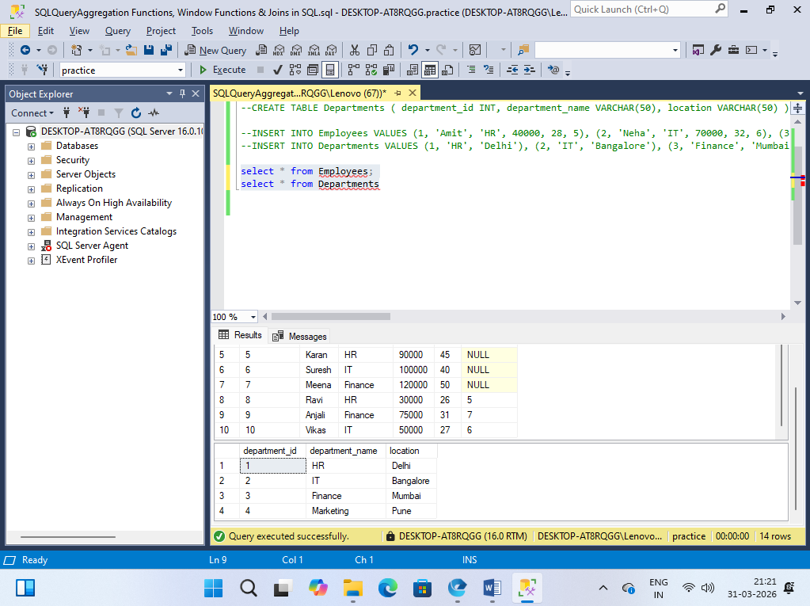

Q1. Write a query to find:
- Total number of employees
- Average salary
- Minimum and maximum salary

select count(distinct(name)) as totalemployee,avg(salary) as avgsalary,max(salary) as maxsalary,min(salary) as minsalary from Employees

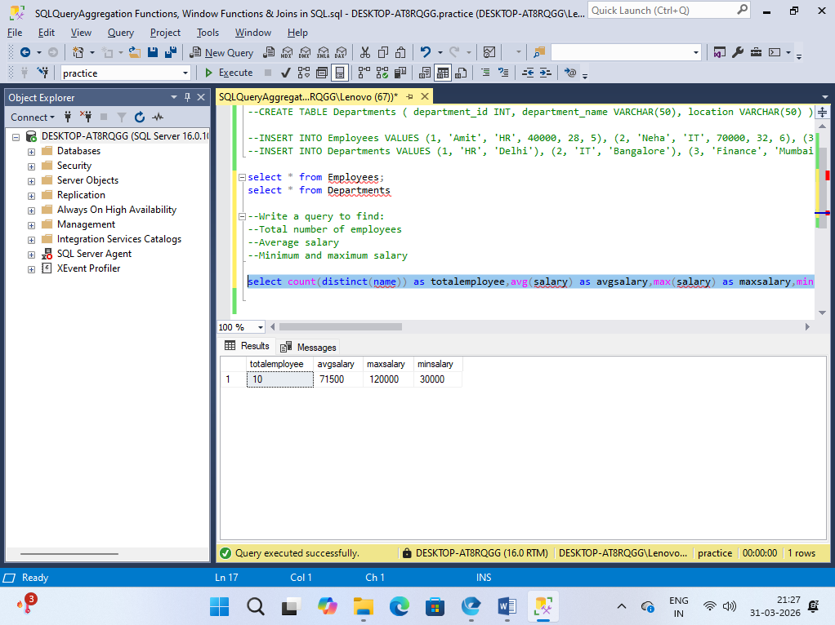

Q2. Find the number of employees with non-null salary values and compare it with total rows.

select count(*) as totalemploye from employees
select count(name) as notnullsalaried from employees where salary is not null

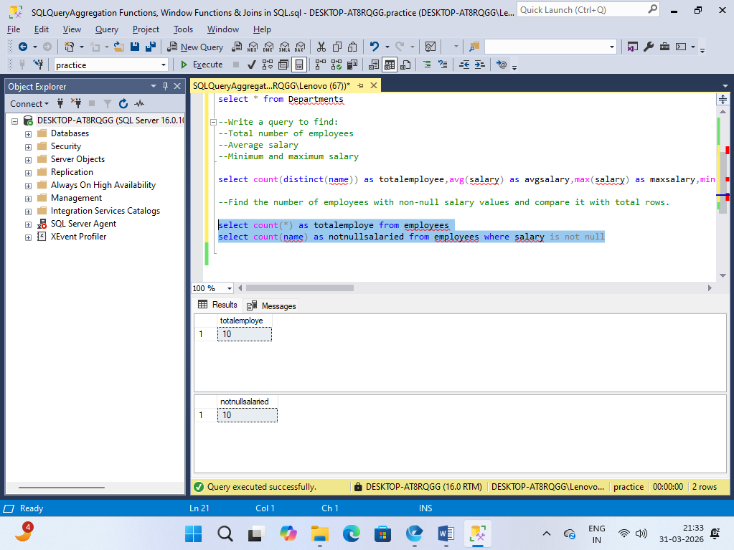

Q3. Display department-wise:
- Total salary
- Average salary
- Number of employees

select d.department_name, sum(e.salary) as Totalsalary,AVG(e.salary) as Averagesalary,count(e.name) as Numberofemployees from
Departments as d
right join Employees as e on d.department_name = e.department
group by d.department_name;

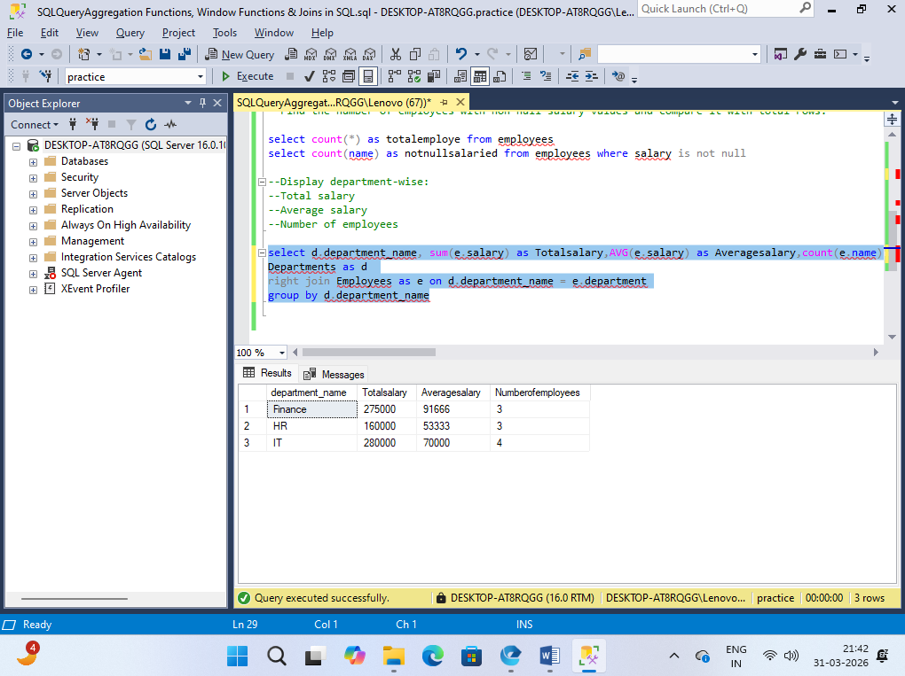

Q4. Find departments where the average salary is greater than 50,000.

select d.department_name , AVG(e.salary) as AvrageSalary from Departments as d
join Employees as e on d.department_name = e.department group by d.department_name
having AVG(e.salary) > 50000

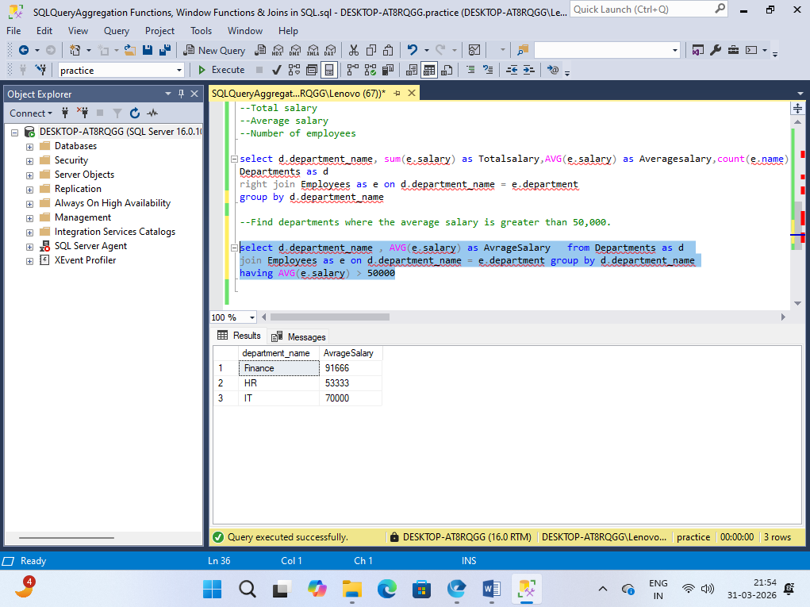

Q5. Write a query to find departments having more than 3 employees.

select department , count(employee_id) as Noofemployess from Employees
group by department having count(employee_id) > 3;

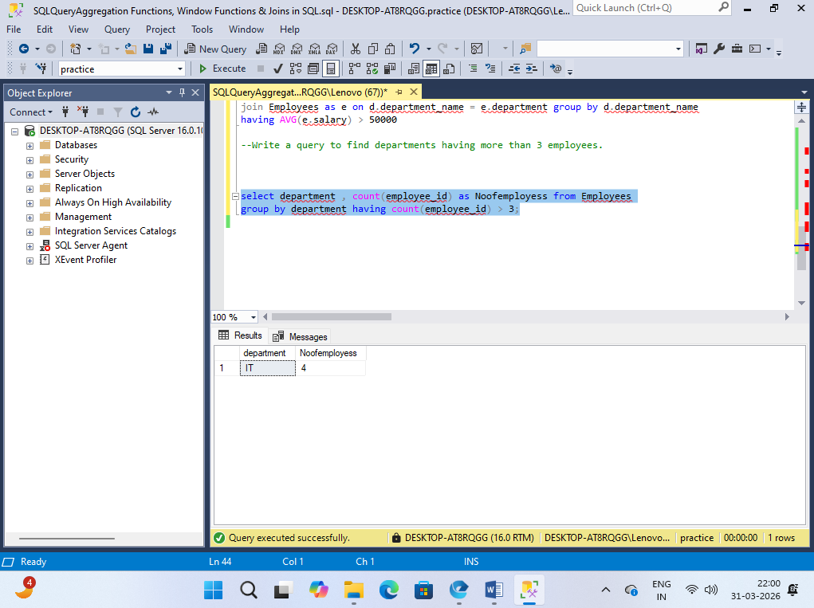

Q6. Find the total salary of employees whose salary is between 30,000 and 80,000.

select count(*) as Noofemployees from Employees where salary between 30000 and 80000

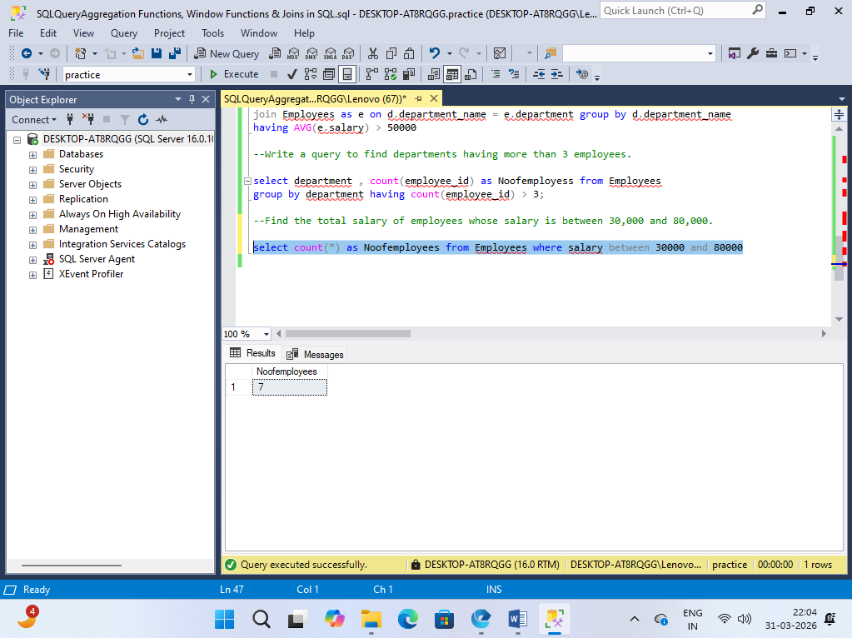

Q7. Using HAVING, filter departments where:
- Average age > 30 AND
- Total salary > 200,000

select department, AVG(age) as Average_age , sum(salary) as Total_salary from Employees
group by department having AVG(age) > 30 and sum(salary) > 200000;

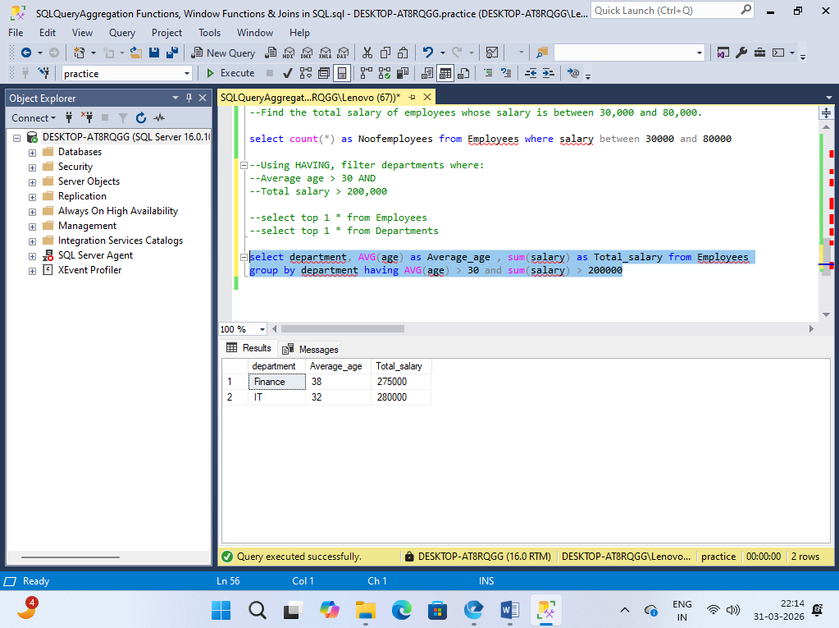

Q8. Find departments where the maximum salary is greater than the overall average salary.

select department , max(salary) as maxsalary from Employees
group by department having max(salary) > (select AVG(salary) from Employees);

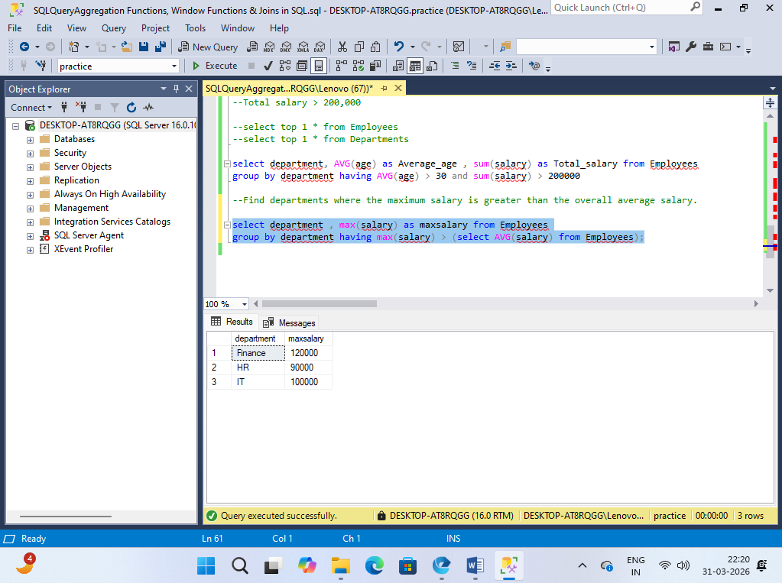

Q9. Find departments where:
- Employee count ≥ 2
- Average salary between 40,000 and 90,000

select department, count(name) as noofemployee,AVG(salary) as Averagesalary from Employees
group by department having count(name) >= 2 and (AVG(salary) between 40000 and 90000);

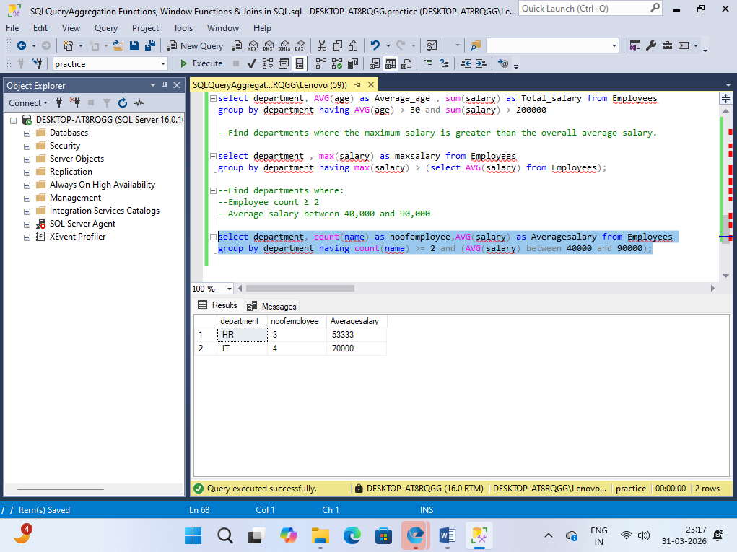

Q10.Write a query to calculate:
Average Salary = SUM(salary) / COUNT(employee_id)
Compare it with AVG(salary).
select AVG(salary) as AVGsalary1, (SUM(salary) / COUNT(employee_id)) as AVGsalary2 from Employees

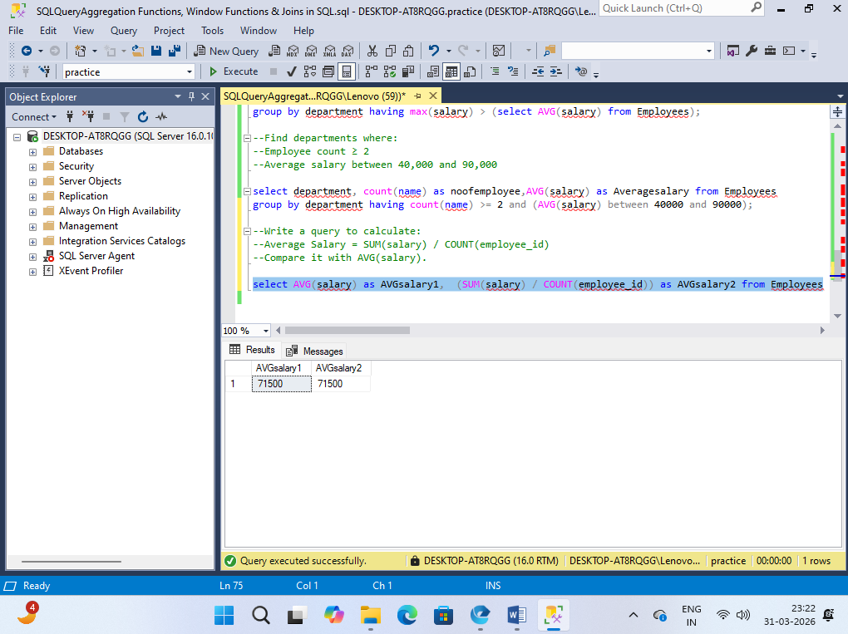

Q 11. Find departments whose total salary is greater than the total salary of 'HR' department.

select department,sum(salary) as Totalsalary from Employees group by department
having sum(salary) > (select sum(salary) from Employees where department like '%HR%');

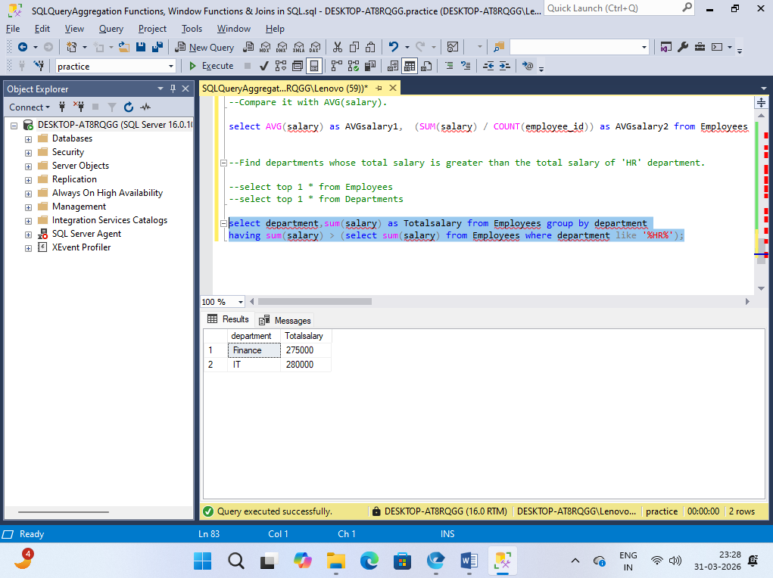

Q 12. Assign a ROW_NUMBER to employees within each department based on salary (highest first).

select name,department,
salary,ROW_NUMBER() OVER (
PARTITION BY department
ORDER BY salary DESC
) AS row_num from Employees;

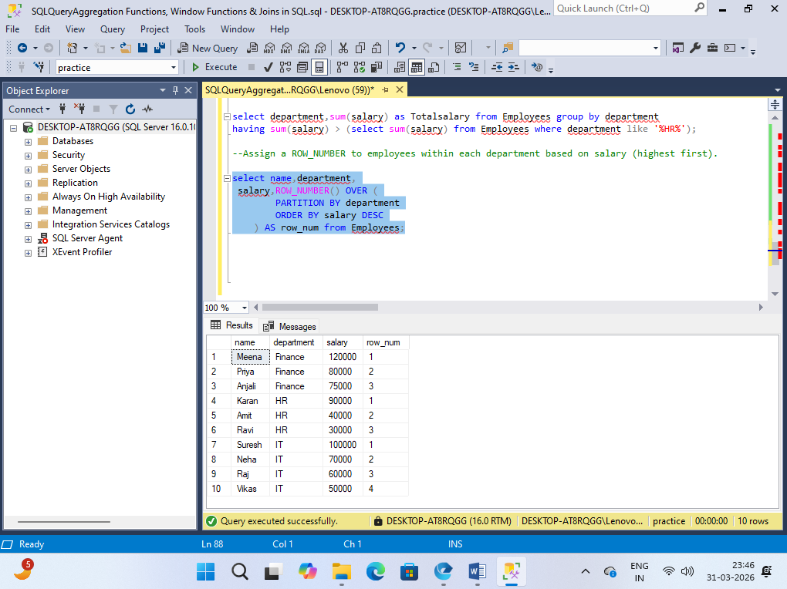

Q 13. Rank employees using:
- RANK()
- DENSE_RANK()
Compare the difference in output.

select name,department,RANK()over(
partition by department
order by salary desc) as Rank_indep,DENSE_RANK() over(
partition by department
order by salary desc) as DENSE_RANK_indept
from Employees

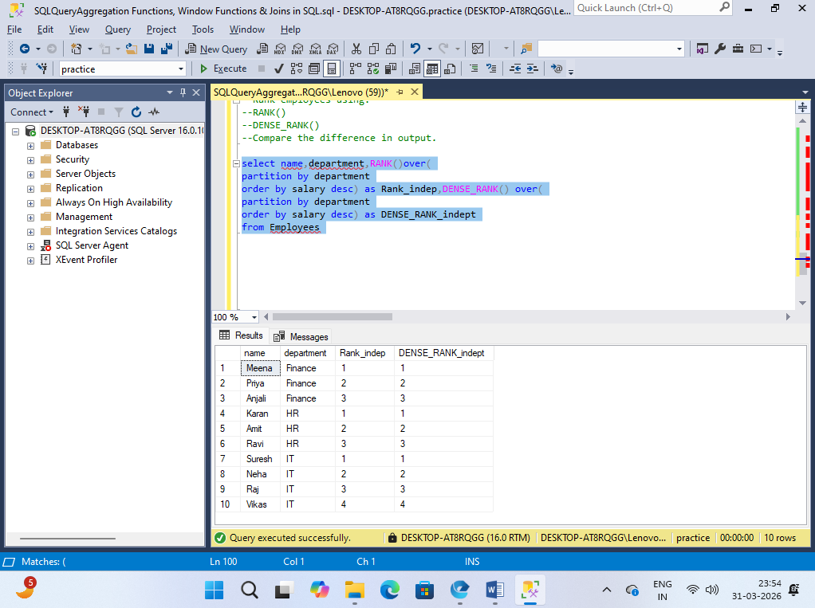

Q 14. Calculate a running total of salary for each department.

select department, sum(salary) as totalSalary from Employees group by department;

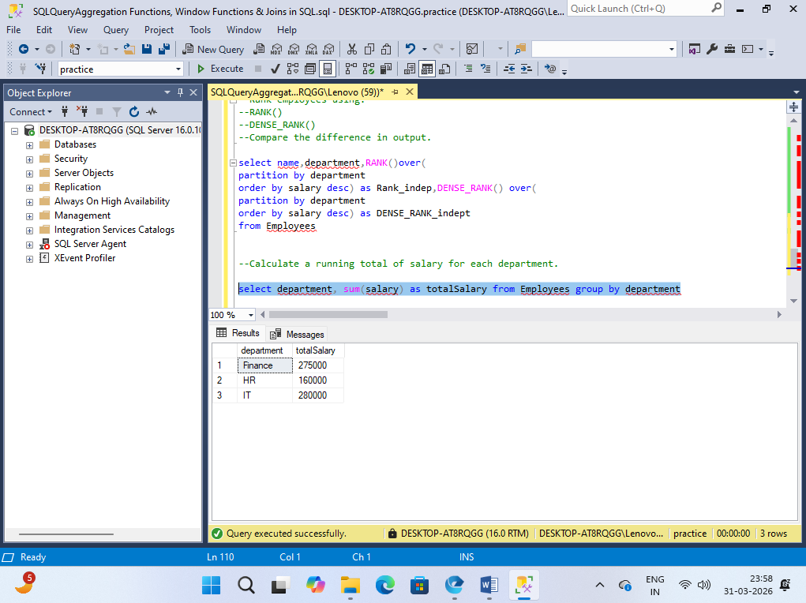

Q 15. Find the average salary of each department using window functions (without GROUP BY).

select department, AVG(salary)over( partition by department) as AVGsalary from Employees

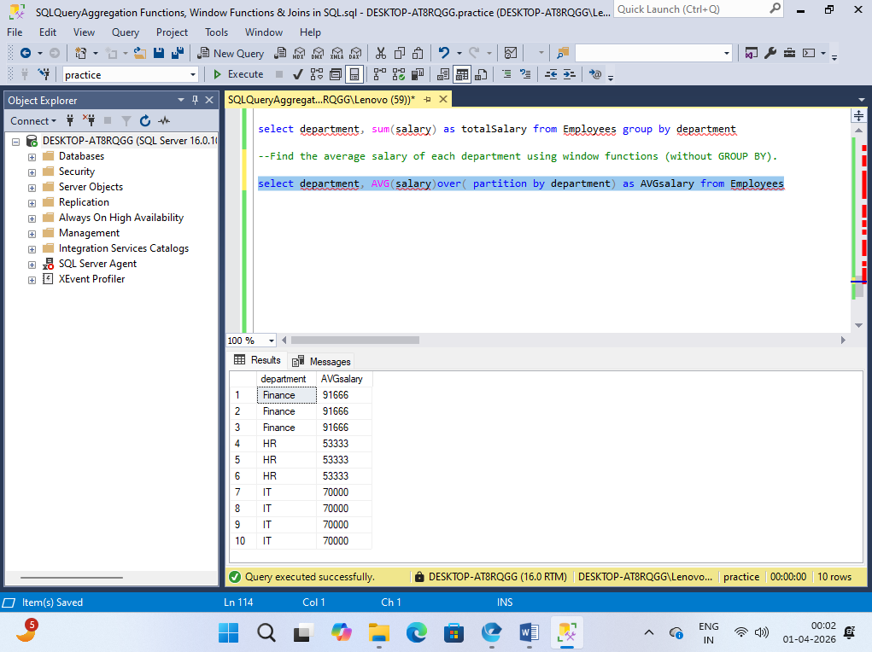

Q 16. Use LAG() to show the previous employee's salary in the same department.

select department , name , LAG(salary)Over(partition by department order by salary desc) as prevEmployeeSalary
from Employees;

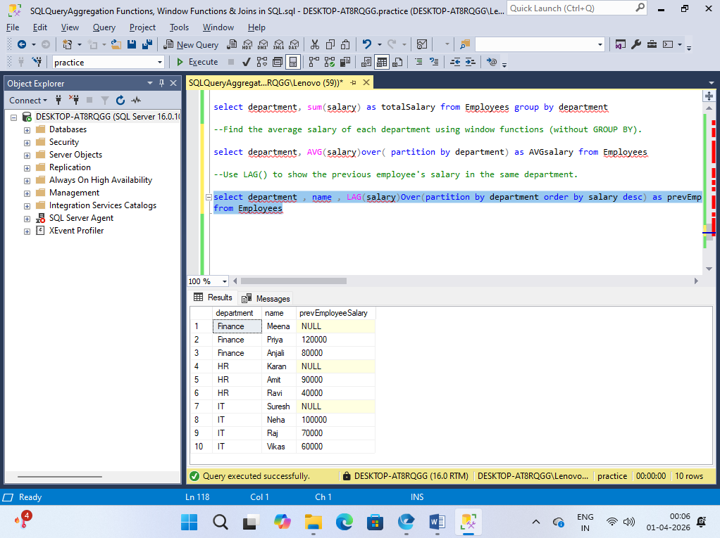

Q 17. Use LEAD() to show the next employee's salary.

select department,name,LEAD(salary) over(partition by department order by salary desc) as nextSalary from Employees;

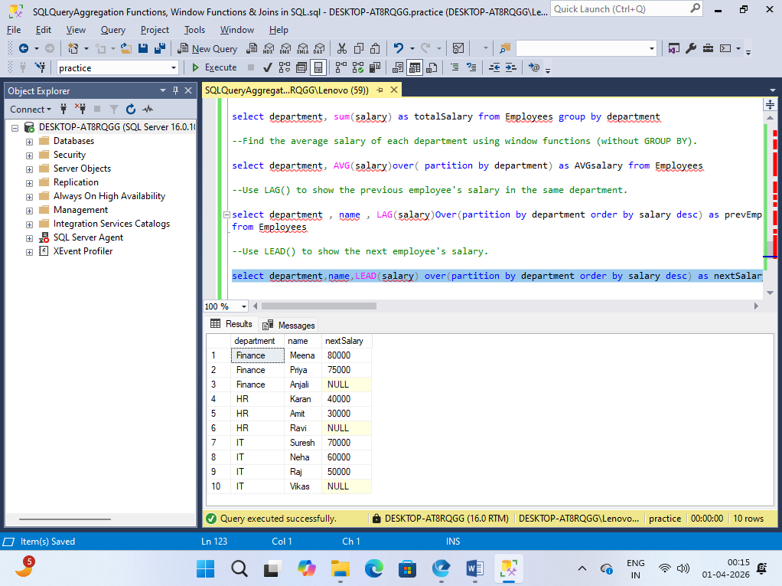

Q 18. Perform an INNER JOIN between Employees and Departments to display:
- Employee name
- Department name
- Location

select E.name,D.department_name,D.location from Employees as E
inner join Departments as D on E.department = D.department_name;

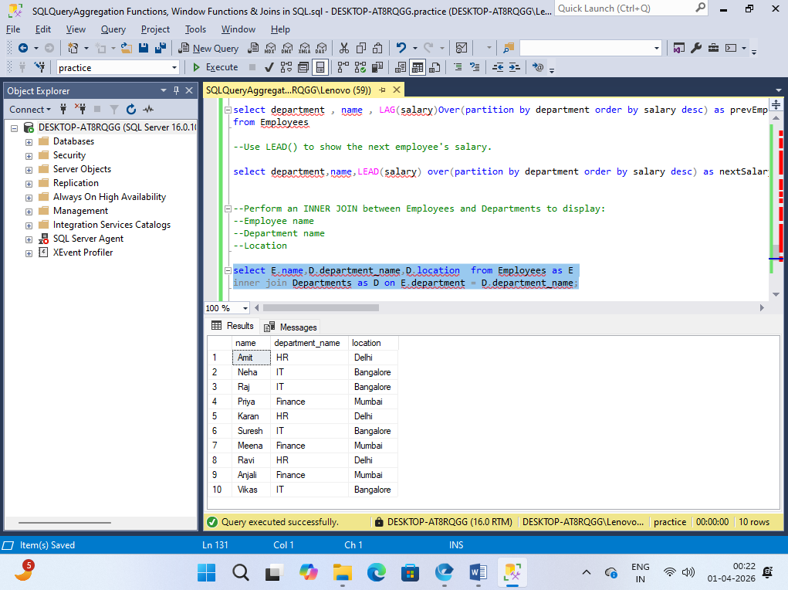

Q 19. Perform a LEFT JOIN and show all employees, including those without matching departments.

select E.name,D.department_name, E.employee_id,E.salary from Employees as E left join Departments as D on
E.department <> D.department_name

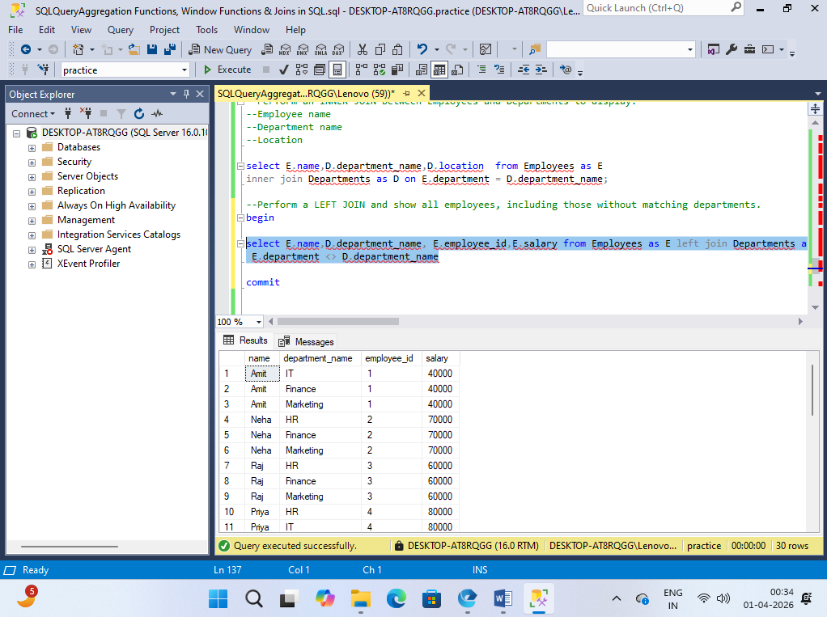

Q 20 . Perform a RIGHT JOIN and identify departments with no employees.

select D.department_name, count(E.employee_id) as noofemployee from Departments as D RIGHT JOIN Employees as E on E.department = D.department_name
group by D.department_name having count(E.employee_id) = 0;

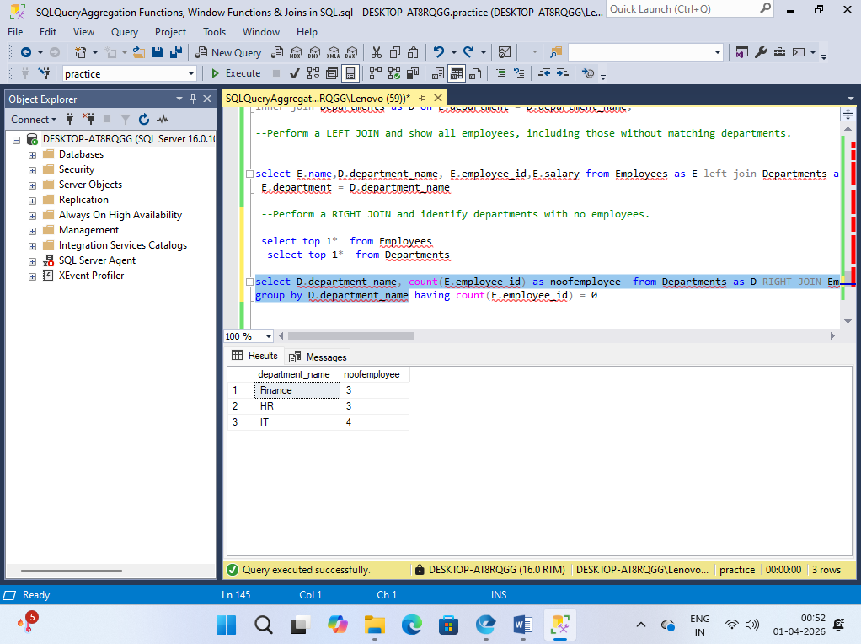

Q 21. Perform a FULL OUTER JOIN and show unmatched records from both tables.

select * from Employees as E FULL OUTER JOIN Departments as D on E.department <> D.department_name;

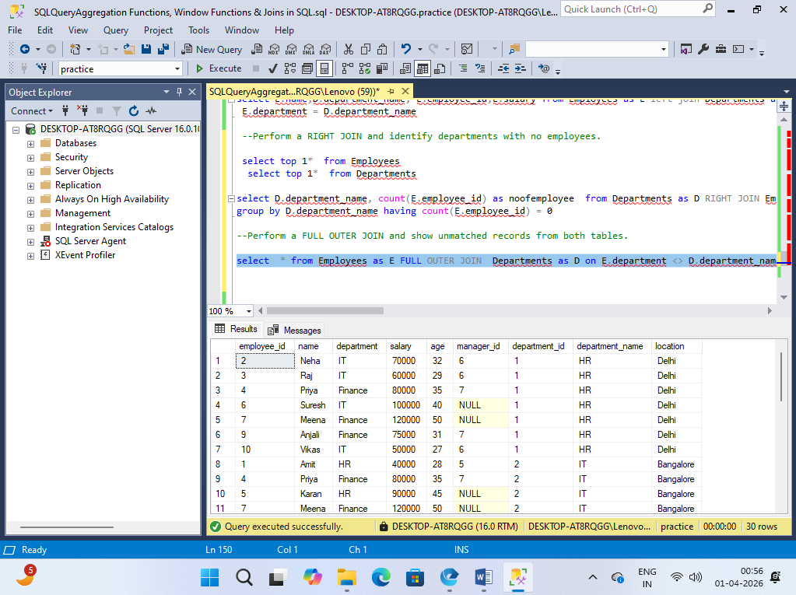

Q 22. Write a query using CROSS JOIN and explain the output.

select * from Employees as E FULL OUTER JOIN Departments as D on E.department <> D.department_name;

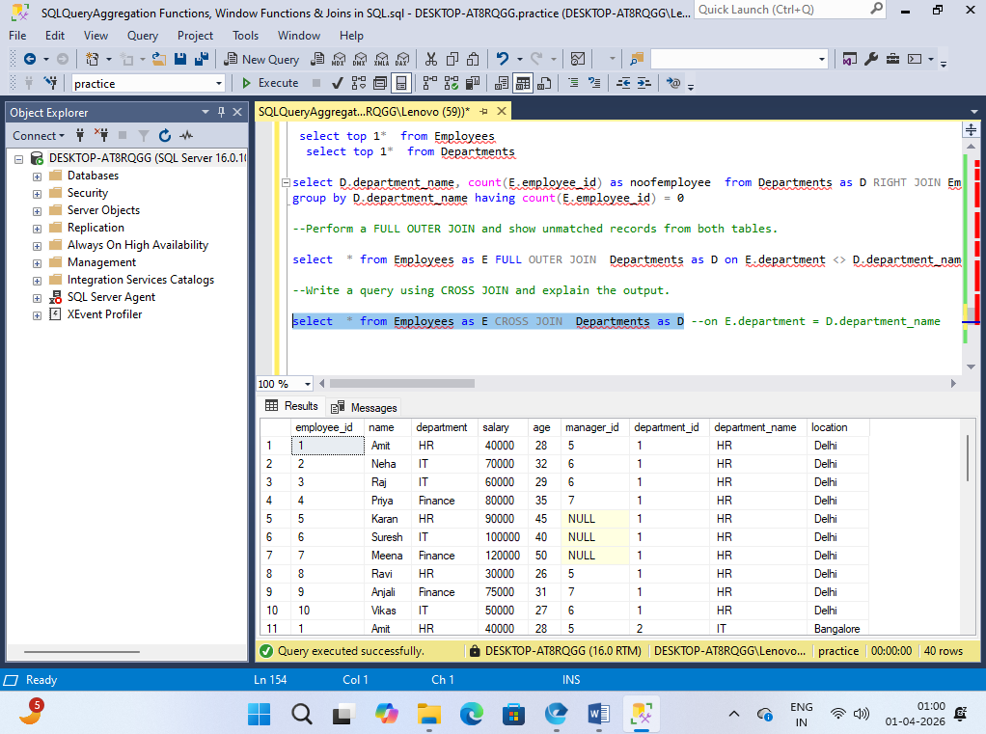

Q 23. Find department-wise total salary using JOIN.

select D.department_name,sum(salary) as totalsalary from Employees as E
join Departments as D on E.department = D.department_name
group by D.department_name

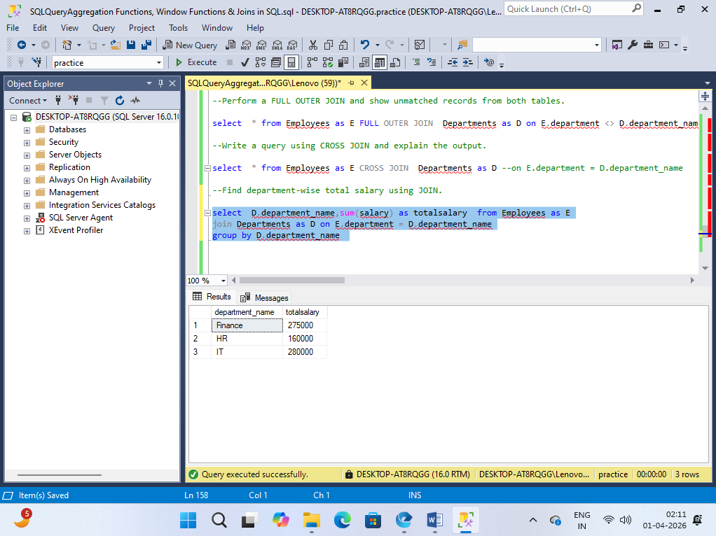

Q 24. Find the department with the highest average salary.

select top 1 D.department_name,AVG(E.salary) as average_salary from Employees as E
join Departments as D on E.department = D.department_name
group by D.department_name order by average_salary desc;

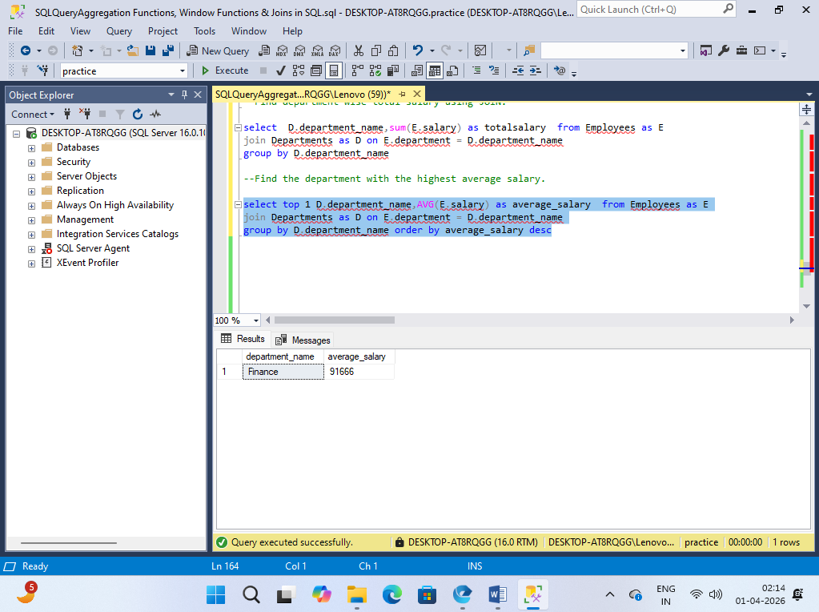

Q 25. Find employees whose salary is above the average salary of their department.

select name,salary,department from Employees as e1
where e1.salary > (select AVG(e2.salary) from Employees as e2 where e1.department = e2.department)

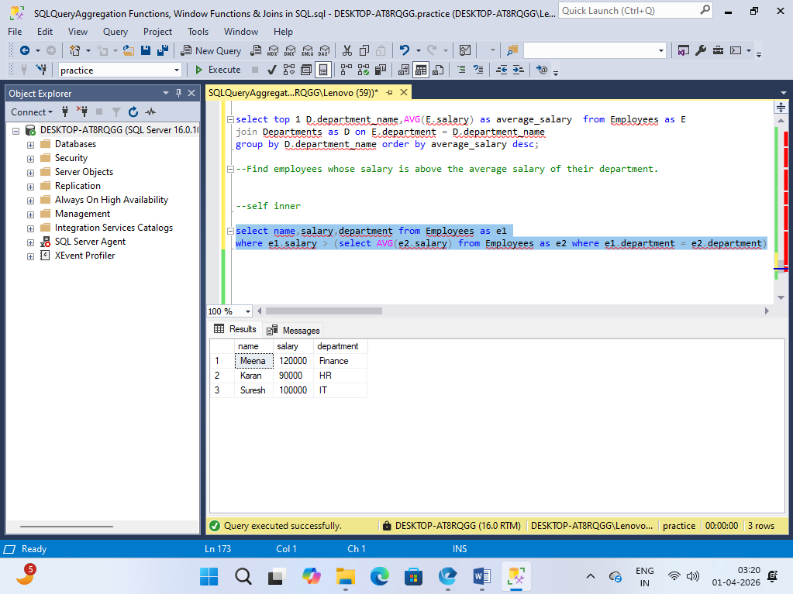

Q 26. Find top 2 highest-paid employees in each department using window functions.

select * from (select e.* ,rank()over(partition by department order by salary desc)as paramitter from Employees as e ) sgrgated where paramitter < = 2;

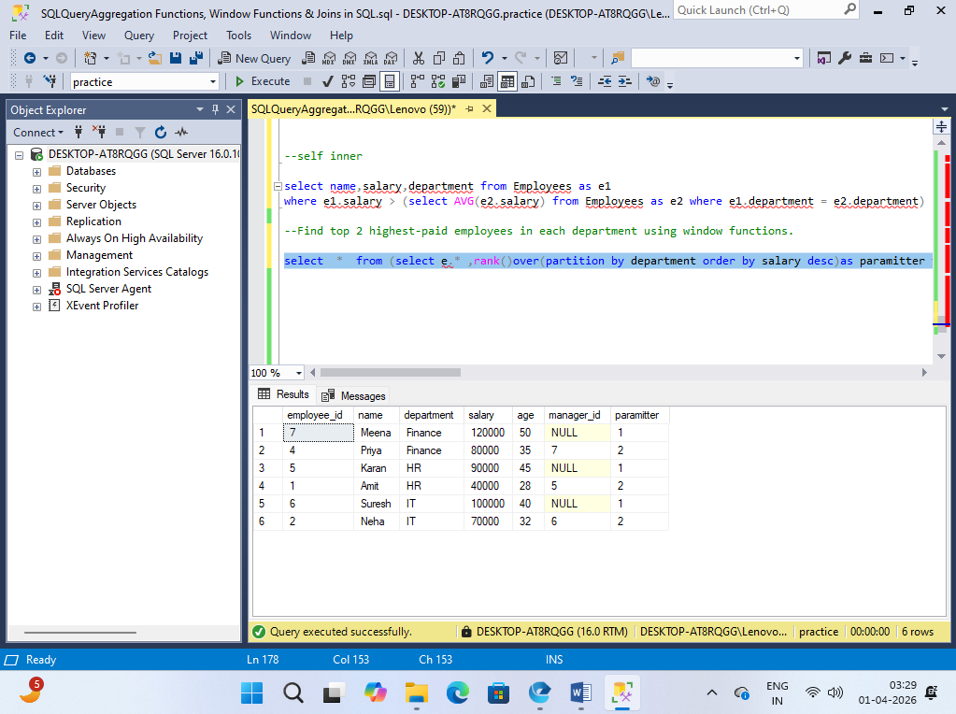

Q 27. Write a query to find employees who earn more than their manager.

select * from Employees as e1 where e1.salary > (select e2.salary from Employees as e2 where e2.employee_id = e1.manager_id);
select * from Employees;

